CMP report 2019-20
The CMP has come like a breath of fresh air t K.V. Kribhco-Surat. It has given a sense of direction to teachers as well as the school administration. School provides the children education with minimum burden and in a play way method. The agenda points of the month end staff meeting or VMC meetings give more weightage to the implimantation of C.M.P.. It seems that all the roads lead to one destination and that is C.M.P.
The teachers on their part, are striving hard to create a child friendly environment in the school. It is only after the introduction and implementation of C.M.P. that the school environment has become more vibrant and contrive to learning. The children look so happy, cheerful and enthusiastic while performing different activities including Cubs and Bulbuls.
The morning assembly gives a very spirited start to the day. Each house is allotted one week to organize the assembly a special programme which helps to motivate the students and nurture them as optimistic individuals. The assembly offers a platform for students to stand up and perform before audience, thus developing confidence in them
The Film Shows and the Power point prasentations, textual videos of the lessons by the teachers are making the teaching so very interesting and motivating for the children that they come forward with their own ideas.
Many activities and programs carried throughout the year for all-round development of the children. i.e.
April- School readiness programme
July- Publishing of class magazine ,plantation
Aug. – Independence day celebration, Cleanliness campaign
Sept. – Hindi Pakhwada, Teachers Day celebration
Following programmes will be conducted in the upcoming months
Oct. –, Annual day
Nov.- Bal divas celebration
Dec. – CMP cluster level cultural meet , Community lunch
Christmas day celebration
Jan.- CMP cluster level sports meet
Feb.- Grandparents day celebration, publishing of CMP News letter

And Various activities and competitions were organized under CCA i.e. Hindi and English calligraphy, Hindi and English poem recitation, Clay modeling, fancy dress, advertisement, Group dance, Group song, Solo dance , Solo song, Rakhi making, Rangoli, Best out of waste, Drawing etc.

The implementation of CMP has brought positive changes in the scool environment and the children will reap the fruits for a long time to come, not only for their own betterment but also for the school and the nation as whole.

The CMP is progressing full stream with all the elements initiated and moving in a promising direction. Class I had PTA meeting with the parents, updated when they were on the readiness programme and activities of the school. CCA Sports and SBSB activities are going on full swing. A film show was screened in the Primary AV room for all the primary student. An effort was made to provide students edition news paper for class IV and V to inculcate the habit of reading. Class library and Open library for primary has received a new sets of books , students happily visits the open library and reading the books. Schedule of Tal ,Integrated, Demo lessons , Peer observation, Discussion and feedback for all PRT’s has commenced.

OPEN LIBRARY

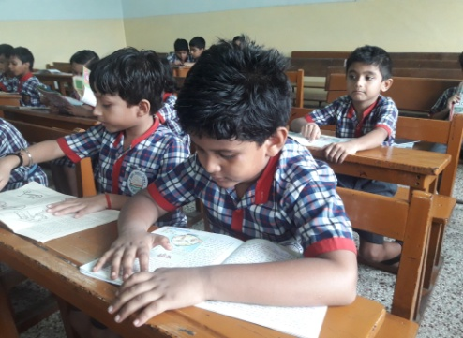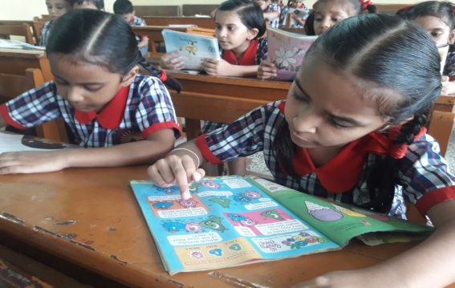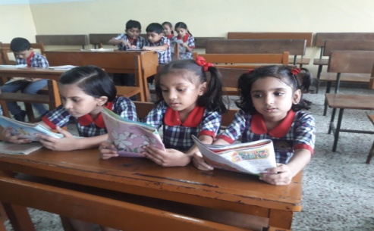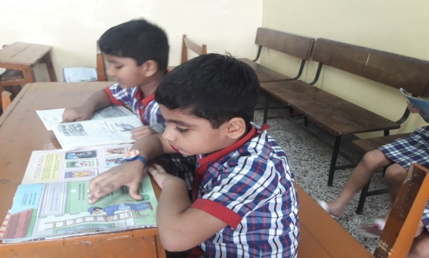

GREETING CARD MAKING
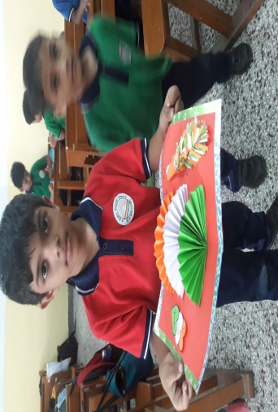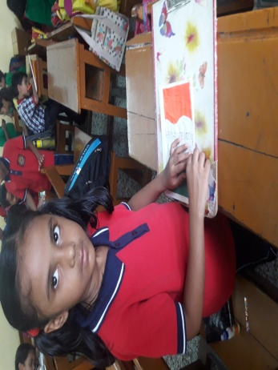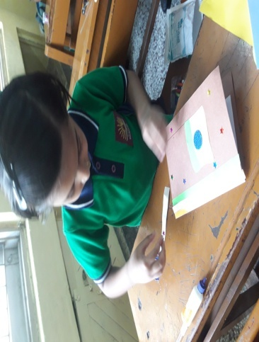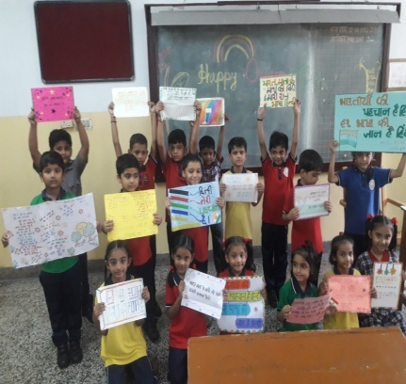

RANGOLI MAKING
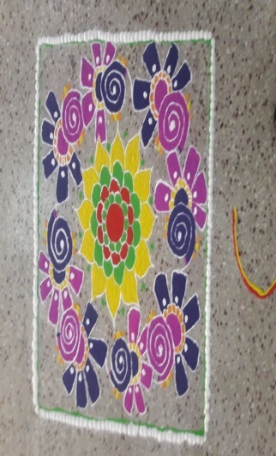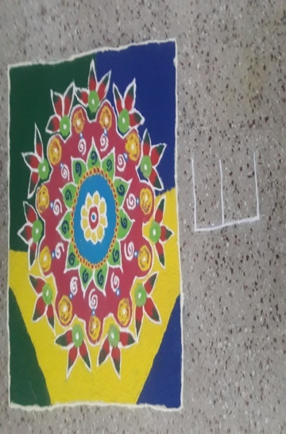
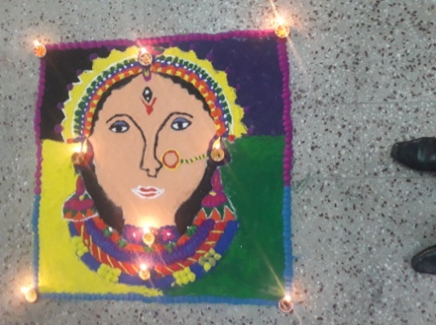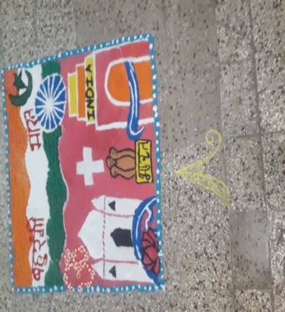

FIT INDIA MOVEMENT

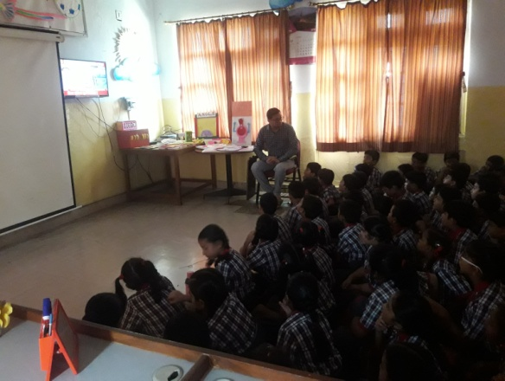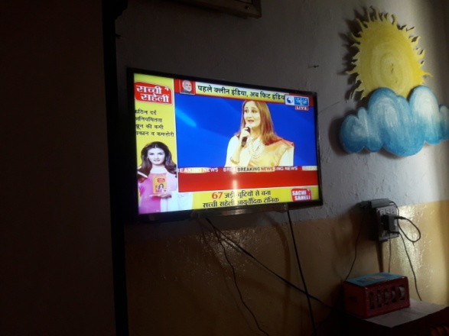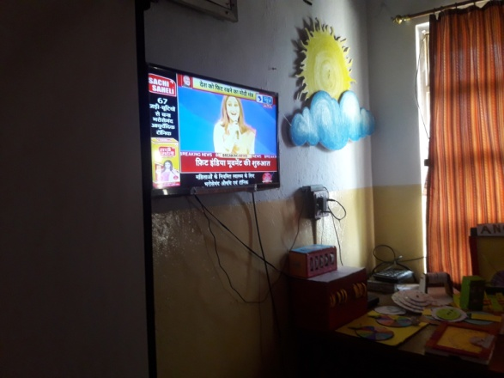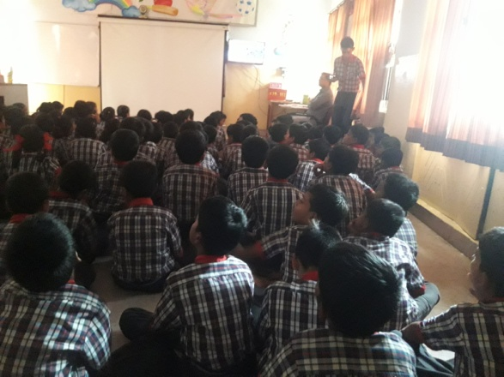

SWACHHTA PAKHWADA
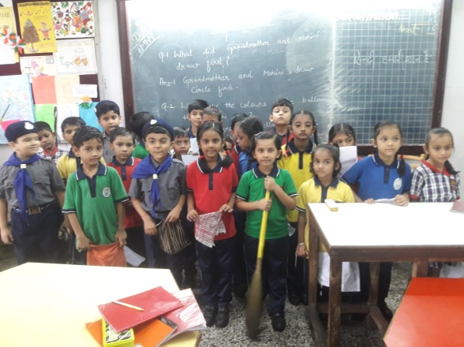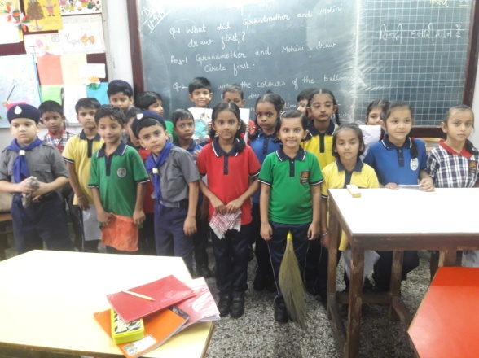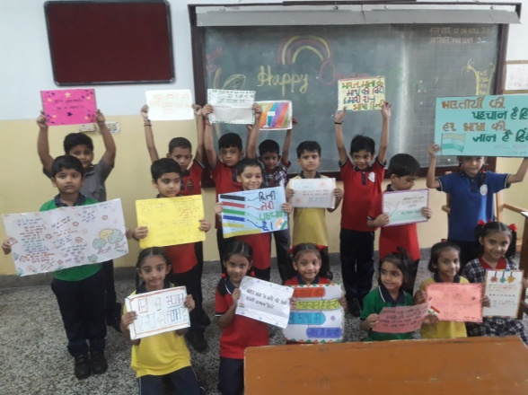
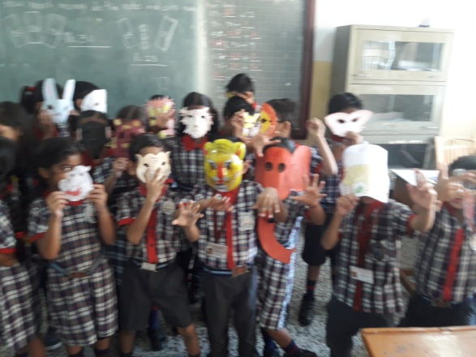2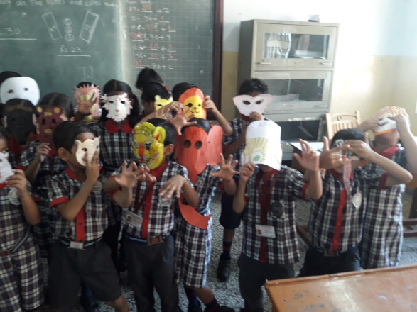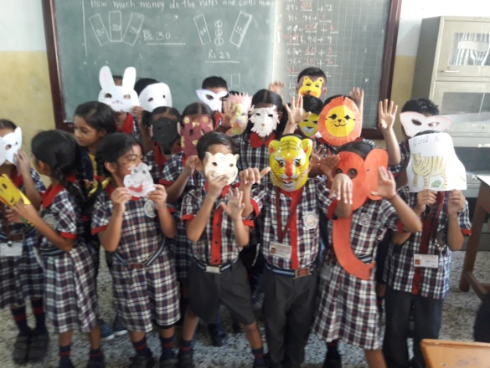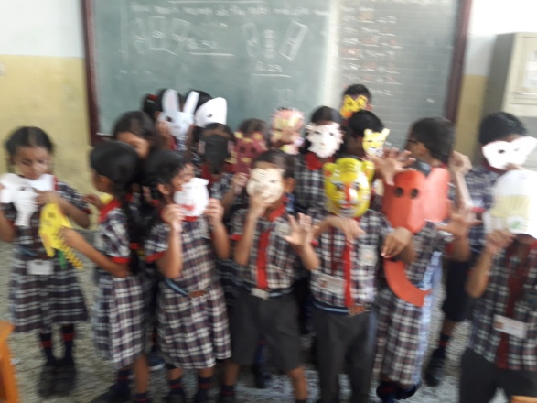

SATURDAY FUNDAY ACTIVITIES

